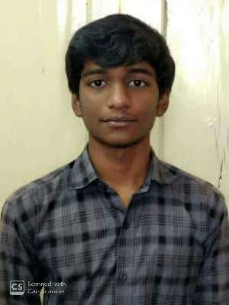

**Alapati Vamsi Krishna Mahesh**

**E-mail:** alapativamsi28@gmail.com

**Mobile:** 6303636267

------------------------------------------------------------------------------------------------

**CAREER OBJECTIVE:**

-**>**Seeking an entry level position to be a part of your organization where I can enhance my Skills and would make a very useful and worthwhile contribution to your organization.

**EDUCATIONAL QUALIFICATION:**

|  |  |  |  |  |
| --- | --- | --- | --- | --- |
| **COURSE** | **NAME OF**  **INSTITUTION** | **PERCENTAGE/CGPA** | **YEAR OF**  **PASSING** | **AFFLIATION** |
| B.TECH  (Information Technology) | Vasireddy Venkatadri institute of Technology. | **Pursuing** | 2022 | Jawaharlal Nehru  Technological  University-Kakinada |
| Diploma | A.A.N.M & V.V.R.S.R Polytechnic College. | **82.3** | 2019 | SBTET |
| SSC | Muncipal High school. | **8.5** | 2016 | State Board |

**COMPUTER SKILLS:**

|  |  |
| --- | --- |
| Languages | C,Basics of Python. |
| Internet Programming | HTML,CSS. |

**CO-CURRICULAR ACTIVITIES:**

* Participated in various cultural activities in interschool competitions.
* Participated in Kabaddi zones in school.
* Got placed in 4th position in shuttle in diploma

**KEY STRENGTH**:

* Quick Learner.
* Communication skills.
* Time Management.
* Multitasking.
* Adoptability.

**PERSONAL DETAILS:**

* Father’s Name : A.Sai Sekhar
* Mother’s Name : A.Rajani
* Date of Birth : 28/12/2001
* Address : Repalle
* Languages known : Telugu,English
* Nationality : Indian

**DECLARATION:**

-**>**I here by declare that the above information is true and complete to the best of my knowledge and belief.

**Place:**Repalle **SIGNATURE:**(A.V.K.Mahesh)